|  |  |
| --- | --- |
| TESLA PALESTINE  Marketing Plan | Arab American University  Data Science and Business Analytics  Supervisor:  Dr. Raed Al-Shomali  Class:  Principles of Marketing  Marketing Team  Ibrahim Tahayneh  Motasem Melhem  Nasri Ishtayeh  Atallah Isayed  Hilal Assaf |

**Contents**

**1.** **Executive summary** 3

**2.** **Current marketing situation** 3

**2.1** **Internal Environment:** 3

**2.1.1 mission** 3

**2.1.2 Resources:** 4

**2.1.3 Offerings:** 5

**2.1.4 Previous Results:** 7

**2.1.5 Business relationships:** 8

**2.2 External Environment:** 9

**2.2.1 Political and legal Factors:** 9

**2.2.2 Economy Factors:** 9

**2.2.3 Social and Ecological Factors:** 9

**2.2.4 Technology Factors:** 10

**2.3 Competitive situation** 10

**2.5 SWOT Analysis:** 13

**3 Target market, customer analysis, positioning** 14

**3.1 Market Segmentation and Target** 14

**3.2 Market Segmentation** 14

**3.2.1 Geography:** 14

**3.2.2Age:** 14

**3.2.3 Gender:** 15

**3.2.4 Educational level:** 16

**3.2.5 Income:** 16

**3.3 Target:** 17

**3.4 Positioning:** 17

**4 Objectives and issues** 18

**4.1 Financial objective** 18

**4.2 Marketing objectives** 18

**4.3 Societal objectives** 18

**5 Marketing strategy** 19

**6 Marketing programs** 20

**6.1 Product and Pricing** 20

**6.2 Place (channels and distribution)** 21

**6.3 Promotion programs:** 21

**6.4 Services:** 22

**6.5 Internal Marketing:** 22

**7 Financial and operational plans** 23

**7.1 Schedule:** 23

**7.2 Budget** 24

**7.3 Revenues and Profit** 24

**8 Measurement and Control** 27

# **Executive summary**

Tesla has established itself as one of the leaders in the Electronic Vehicle market and a leader in different innovations and technologies. In order to further control the EV market, we have developed a strategy to dominate the market with an entry level, luxury electric vehicle that will maintain Tesla’s core values and will allow it to compete on a broader scale with electric vehicles. After taking everything into consideration, we believe that our strategy will allow Tesla to gain a good market share within the Palestinian market, gain brand awareness, generate brand loyalty and earn profits through our new channel. Tesla has developed a brand new, entry level luxury sedan that is fully electric and named the Tesla Model 3 which has the core components of a Tesla vehicle, but it was created with a budget in mind to grow the potential target market.

This will allow more customers to get their hands on a fully electric vehicle at an affordable price which will be cheaper than many other entry level luxury vehicles in Palestine, while still being able to grow the Tesla brand. We will also introduce a variety of programs in order to improve brand loyalty as well as giving more options for purchase, including the Test Drive programs within different West Bank cities. We will also launch a marketing campaign with advertisements in different social media channels and through other web sources to raise the awareness and the interest about Tesla and Tesla Model 3 in particular in Palestine.

# **Current marketing situation**

## **Internal Environment:**

### **2.1.1 mission**

***Tesla’s mission is to accelerate the world’s transition to sustainable energy.***

Tesla, Inc. previously known as Tesla Motors Inc., is a publicly held automotive and technology firm that designs and builds electric vehicles as well as scalable clean energy generation and storage products. The company is headquartered in Palo Alto, California, with Robyn Denholm at its helm as Chairman of the Board, Elon Musk at its helm as CEO, and Chief Product Architect. With 2019 revenues of $24.578 billion, its income sources are mostly consumers, who prospect and purchase its vehicles through boutique-style stores, in a unique process that is absent of sales personnel or negotiation of any kind. Tesla’s electric automobile product portfolio includes the Model S, Model X, Model 3, and Model Y.

### **2.1.2 Resources:**

#### **2.1.2.1 Human Resources**

In order to provide our services, we need trained and professional staff to serve our customers. Our staff will be from different fields mainly in marketing, sales, supply chain, finance, administration and engineering. In general, there are many local qualified professionals who can join us. In order to ensure the proficiency, specialized trainings will be helped to ensure the proficiency level, especially in TESLA's vehicle maintenance.

* Pre-Sales Employees
* Marketing Employees
* Maintenance Engineers
* Showroom Manager
* Warehouse Manager
* Logistics Manager
* Finance Manager

Outsourcing Services:

* Cleaning
* Legal advisor
* IT Support

#### **2.1.2.2 Financial Resources**

Tesla is a publicly traded company that trades at NASDAQ under TSLA. The company's total assets have continued to increase since 2017, $28.655B to $29.74B in 2018 and then $34.309B in 2019. Equally, the company's total liabilities have experienced an equal measure of increase with 2019 recorded as the highest year with high levels of liabilities ($26.842B). The company's total stockholders’ equity has risen from $5.235B, in 2017, to $5.757B in 2018, and then $7.467B in 2019. The company gross margin for 2019 was $24.58B, operating at a margin of 16.56%. The return on investment has remained low at -0.39%. The intensive capital nature of the company investment has been associated with the observed figures.

**2.1.2.3 Informational Resources**

We have used different sources of information to get the most comprehensive image about the Palestinian market, and the purchasing power of Palestinian consumers and their demographic information, some of which are listed below:

* Ministry of Transportation (MOT).
* Vehicles Importers Association.
* Used Vehicles Importers Association.
* Palestine Monetary Authority (PMA).
* Palestinian Central Bureau of Statistics (PCBS),
* Tesla Internal Information
* Ministry of Commerce
* Palestine Capital Market Authority (PCMA)
* Data from social media and internet about the Palestinian market

#### **2.1.2.4 Supply Resources**

We will be contracting with various supply, freight and clearance companies to guarantee uninterrupted supply chain, the reason behind choosing multiple companies is to guarantee the independence from using only supplier, they will be responsible about delivering vehicles and parts from the mother company warehouses or manufacturing facilities, in addition to the dealing with the Israeli Authorities.

### **2.1.3 Offerings:**

The company products fall into three categories: electric luxury vehicles, automotive components, and rechargeable energy storage systems. Under the electric luxury brand, the company has offered various product lines of significant importance under this banner is the Model 3 product line and the other model to be released, Model Y. The company has patent rights for Electric power trains and other related products. Equally, the company has invested significantly in the production of rechargeable power products and the establishment of Recharging stations. The following table shows the current vehicle lineup.

|  |  |  |
| --- | --- | --- |
| **Table 1: Vehicles produced by Tesla** | | |
| **Product** | **Description** | **Base price (USD)** |
| Model 3 | 4 Door  Hatchback  Compact Sedan | 41000 |
| Model Y | 4 Door  mid-size SUV | 48000 |
| Model S | 4 Door  Hatchback  Sport Sedan | 80000 |
| Model X | Four Door  Hatchback SUV | 85000 |
| Roadster | Two Door  Removable hardtop convertible coupe | 200000 |
| Semi | Truck  18 Tons | 150000 |

After studying different customer’s needs, wants, purchasing power and the current market dynamics in Palestine we found that the model 3 has the most potential in breaking into the Palestinian market and sell in big numbers.

### **2.1.4 Previous Results:**

Tesla’s total revenue has exploded since 2010, as its total revenue has increased by at least 110% every fiscal year from the previous fiscal year since 2010. Tesla saw its greatest total revenue increase in 2013 when its total revenue boomed by 487% from the previous of 2012, and broke the billion mark as it reached a total revenue of 2.01 billion dollars. The following table shows the total annual revenues from 2010 to 2019.

|  |  |
| --- | --- |
| **Table 2: Tesla’s annual revenue (Millions of USD)** | |
| **Year** | **Total revenue** |
| 2019 | $24,578 |
| 2018 | $21,461 |
| 2017 | $11,759 |
| 2016 | $7,000 |
| 2015 | $4,046 |
| 2014 | $3,198 |
| 2013 | $2,013 |
| 2012 | $413 |
| 2011 | $204 |
| 2010 | $117 |

Tesla’s primary industry is the electric automotive industry (based on the percentage of Tesla’s profit allocated to automobiles). Here is a graph that visualizes Tesla’s sales across each of its Market segments for the last two year.

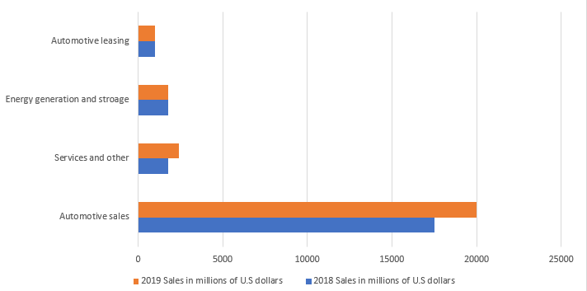

Chart 1: Tesla Sales across each of its market segments.

### **2.1.5 Business relationships:**

As an international company opens its first branch in Palestine we will need to establish multiple partnerships with different local companies to facilitate our operations, key partners will be as listed below:

* Construction companies to build infrastructure for supercharging stations, service center and the showroom.
* Municipalities to identify charging stations locations
* Supply chain companies
* Clearance companies
* Freight companies
* Delivery companies
* Gas-stations to setup charging stations
* Towing service companies
* Security companies
* Cleaning and housekeeping service companies
* Leasing companies

## **2.2 External Environment:**

We have evaluated the external variables to identify opportunities and general risks that would lead to major market changes in the long run. Therefore, we classified the factors under the following categories:

### **2.2.1 Political and legal Factors:**

The Palestinian market is volatile and has been largely affected by the political changes surrounding it, including the division in the Palestinian political scene and the Israeli occupation limitations, which controls most of the Palestinian territories in addition to the borders. Therefore, it is an unstable environment, there is so much uncertainty in the Palestinian political horizons. Especially with the Israeli government's decision to annex around 30% of the Westbank. As for the laws, the government has enacted laws that encourage the possession of electric vehicles, such as reducing the electric vehicle tax to 10% of the total vehicle value instead of 75%+ for combustion engines vehicles, and the Israeli government has also enacted laws that prohibit the import of combustion engine vehicles by the year 2030. These laws encourage customers to own electric vehicles.

### **2.2.2 Economy Factors:**

The Palestinian economy is affected by a set of factors that directly and indirectly affect the development of the Palestinian economy, such as high unemployment rates, high public debt, and high interest rates. Israel also controls the Palestinian economy through economic agreements that impose import and export restrictions. These economic factors influence the purchasing power of customers.  
 On the other hand, the historical data from the previous year’s show stable growth in new vehicles demand, and that can be explained by the poor public transportation system in the Palestinian territories, another encouraging factor is the high fuel prices in Palestine due to high taxes imposed on fuel, which can be a great motivator for people to prefer Electric Vehicles over combustion engine vehicles.

### **2.2.3 Social and Ecological Factors:**

In recent years the attention for the environmental effects of using oil based products have been incrementing and affecting the health of the communities, due to these reasons the government have implemented some policies to encourage people to use more environmentally friendly products and sources of energy such as the reduction of taxes on EVs and the increased taxation on fuel and combustion engine vehicles.

The climate in Palestine is moderate and natural disasters are rare. Therefore, it is considered a suitable environment for investments, especially since Palestinian laws encourage investments in environmentally friendly areas.

### **2.2.4 Technology Factors:**

In recent years the Palestinian economy has been booming in technology perspectives, specially that 3G was finally allowed for Palestinian operators, which would allow Tesla`s “over the air updates” in addition to constant connection and feedback from Tesla`s servers.

The development and adoption of mobile technologies presents many opportunities for Tesla to reach its target customers in an effective and efficient manner.

In addition to the above, the percentage of Palestinian internet connected homes is relatively high compared to the region, this indicates that it wouldn’t challenging to request customers to make their purchase from the website.

## **2.3 Competitive situation**

To address the competitive situation, we had to look at the current EVs sold in Palestine which are as below:

1. NISSAN LEAF (Salon)
2. PEUGEOT PARTNER (Commercial)
3. Jaguar I-Pace (Luxury SUV)
4. Citroen Berlingo (Commercial)
5. Hyundai Sonata

Knowing that Palestine has just hopped on the EV train it’s been less than 5 years since the start of selling EVs in Palestine, this gives us a great opportunity to be one of the pilots of selling EVs in Palestine.

We also should expect many other vehicle dealerships to start selling EVs specially because battery systems are getting cheaper, petrol in Palestine is one of the most expensive commodities, and lastly the taxes on EVs (10%) is way much cheaper than it is for petrol or Diesel vehicles (75%+), for the above reasons it will encourage all vehicle dealers to start bringing EVs more to Palestine.

Our strategy to address competition`s attempt to dominate the market is by always providing the better alternative, as it’s known Tesla`s battery pack is the most efficient in the market, in addition to the fact that it’s not too expensive compared to its rivals in EVs or in combustion engines.

Also, a great point of advantage for us in TESLA is the fact that TESLA has been in the EVs market the longest (since 2010) which made Tesla at the top of EV sellers globally, On the other hand, since we don’t have much competition from EVs in Palestine we should compare to equivalent traditional combustion engine vehicles and hybrid vehicles

If we want to compare according to level of luxury and the price range we would be looking at the below models and make:

1. BMW 3 series
2. Mercedes Benz C Class
3. Kia optima hybrid
4. Audi A4
5. Hyundai Sonata Hybrid
6. Jaguar XE
7. VW Passat
8. Skoda Superb

The above models and make are the closest to Tesla model 3 in terms of price and comfort/luxury and type, to address these types of vehicles we need to make it clear that our Tesla model 3 is better in running cost, maintenance, durability, and safety.

**2.4 Market situation**

Palestine is considered a relatively small country the furthest distance from Hebron in the south to Jenin in the north is less than 200KM which makes it possible to cross the country from north to south on one charge, this is a great selling point that is not available in other larger countries.

Another important point is that Palestinian cities are relatively small, some people`s trips to work are -on average- shorter than 10KM, which means they wouldn’t need to charge the vehicle once every one or two weeks.

The number of licensed vehicles in Westbank is 79.4 private vehicles per 1000 Capita, and the number of newly registered vehicles is around 32,000 vehicles annually, Private vehicles represent 84% of that number, equivalent to approximately 27,000 private vehicles annually, 5000 of which are zero mileage vehicles, where 98% of them are powered by fuel, with hybrid vehicles and EVs make up a very small percentage.

The Palestinian market is covered for many years by many of the major vehicle manufacturers such as BMW, Audi, Jaguar, Volkswagen, Skoda, Seat, Mitsubishi, Cadillac, Mercedes-Benz, Alfa-Rome, Land-Rover, Hyundai, Kia, Peugeot, Citroen, Chrysler, Fiat, Chevrolet, Ford, Mazda, Opel, Isuzu, Renault, SsangYong, and Dacia.

This is a big positive sign that the Palestinian Market is an attractive automobile market and the previously mentioned Dealerships are a good proof of that.

Palestinian Consumers tend to spend a lot on their vehicles as most new vehicles prices start from 120000 shekel, which will make it easy for us to position ourselves in average/above-average category.

Palestinian consumers in general look for several key factors before buying a vehicle most relevant of which are:

* Safety (Five-star rating by the American National Highway Traffic Safety Association)
* Cheap to run (cost per KM for electric vehicles is significantly lower than Combustion engine vehicles)
* Cheap to maintain (there won’t be a need for regular oil changes or any drive train issues)
* Ride comfort and durability
* Great looks

Tesla vehicles excel in all five factors above, which sets it comfortably in a very competitive position in the Palestinian market.

The price of fuel in Palestine is very high compared to the Arab countries, as it reaches in Palestine more than twice the price in Jordan, due to the association of Palestine with the price of fuel in Israel. Also, fuel prices in Palestine are very high compared to the income level.

## **2.5 SWOT Analysis:**

|  |  |
| --- | --- |
| **Table 3: SWOT Analysis** | |
| **Strengths** | **Weaknesses** |
| * Clean energy * Five Stars Safety (one of the safest vehicles in the world) * Luxury and sporty design * Auto navigation * Strong market position and brand recognition * Strong focus on Research and Development * Low running cost | * Fluctuation in the production material * Small segment to target including early adopters. * The number of power charging grids is small * Poor customer’s awareness * Poor mapping of Palestine which limits the usefulness of Tesla`s navigation system. |
| **Opportunities** | **Threats** |
| * Clean energy support by governments * Low customs rate on EVs * Minimizing pollution. * Growing support of the Palestinian governments for clean energy * High fuel prices. * Innovative Technology * Demand increase of luxury vehicles * Israel targets to ban import of Combustion engines by 2030 | * Paris agreement restrictions * Dependent electrical infrastructure in Palestine * Collapse of the Palestinian economy * Newcomers * Doubtful customers towards EVs * Political unrest * The absence of electric-friendly infrastructure. |

# **3 Target market, customer analysis, positioning**

## **3.1 Market Segmentation and Target**

Consumers of luxury vehicles in Palestine are looking for reliability, durability, and the latest technological developments in a vehicle that reflects their social situation.

## **3.2 Market Segmentation**

The Palestinian market was divided according to Tesla based on geographical distribution, demographic, and psychographic factors.

### **3.2.1 Geography:**

The population in Palestine is divided into three groups, which are cities, villages and camps. We will start in the main cities in the West Bank, which are Nablus, Jenin, Tulkarem, Ramallah, Hebron, Bethlehem, Jericho, Salfit and Tubas. As these areas contain the largest population as well as target customers.

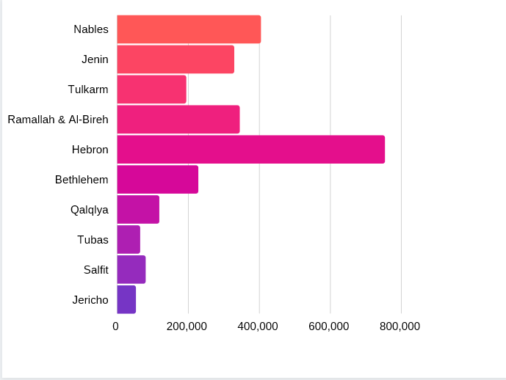

Chart 2: Population per Governate

### **3.2.2Age:**

It's safe to assume that electric vehicles will be embraced by younger generations between the ages of 30-55.

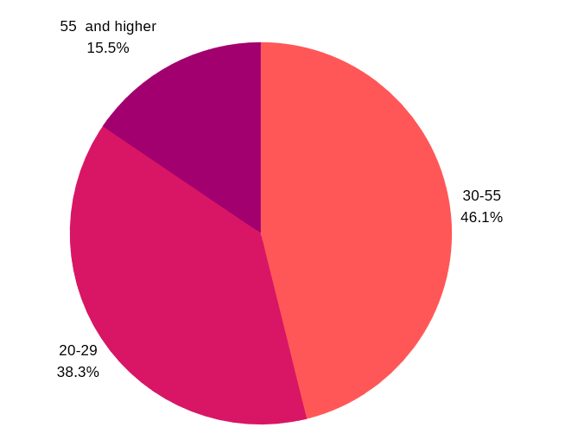

Chart 3: age groups and their percentages in Palestine

### **3.2.3 Gender:**

Males in Palestine constitute the largest proportion of workers in the government and private sector at 72.6%. The same applies to the fact that 90% of men are the main source of income for the Palestinian families.

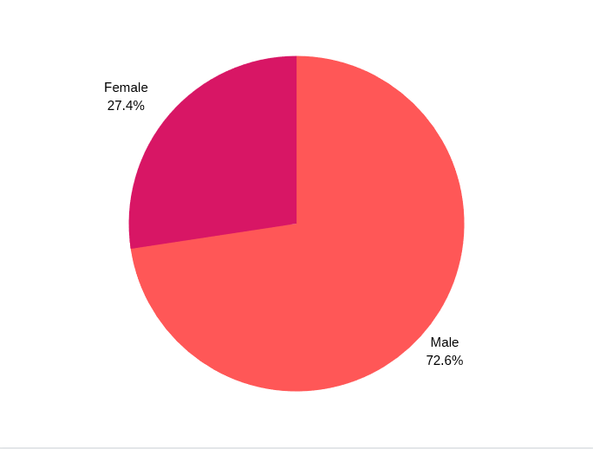

Chart 4: work force distribution according to Gender

### **3.2.4 Educational level:**

The education level was analyzed for our age group (30-55) and got divided into the below categories:

1. People who hold a master’s degree and above
2. People holding a bachelor’s degree
3. People with diploma
4. people without college degree.

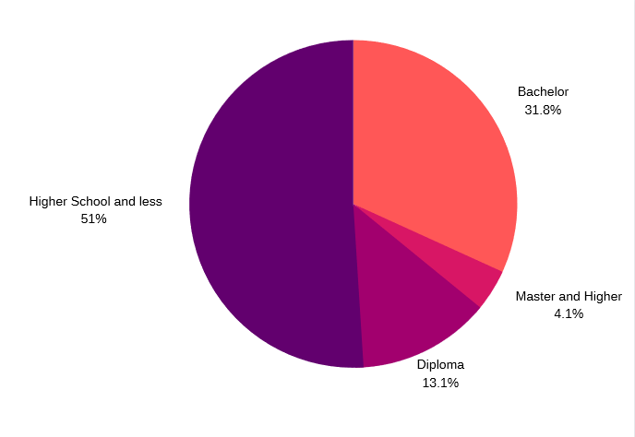

Chart 5: Education level for age group 30-55 years

### **3.2.5 Income:**

The population was divided according to annual income to the below categories:

1. Less than 9000 dollars
2. 10,000 to 150,000
3. 15,000 to 25,000
4. 26,000,000 to 36,000
5. Above 36,000

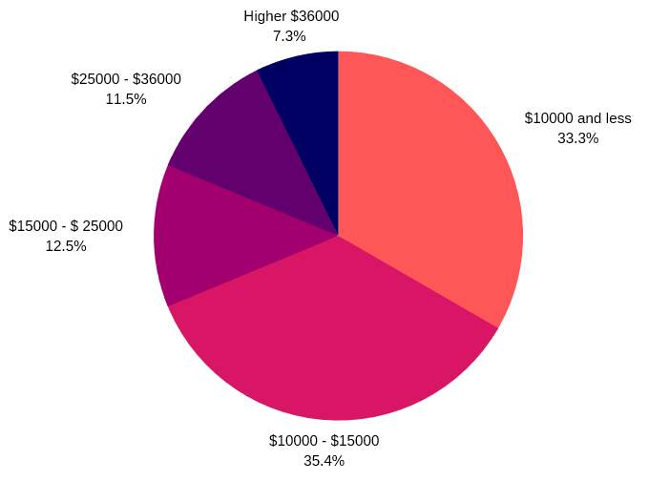

Chart 6: annual income for age group 30-55 years

## **3.3 Target:**

Our target market in Palestine is the upper-middle class and the upper class, who can afford owning a luxury vehicle like Mercedes, BMW or Audi. And interested in electric vehicles in order to save on expenses from Fuel consumption or a first adopter to new technologies.

**SEGMENT ONE: Upper-Middle Class**

This segment of the Palestinian society holds university degrees and working in prestigious occupation and want to get luxury vehicles to enhance their social status.

**SEGMENT TWO: Upper Class**

This segment is very important, and they are businessmen who own luxury vehicles that suit their social status. And they are always looking for renewal and owning brand new vehicles.

## **3.4 Positioning:**

* The Tesla Model 3 is an innovative high-performance electric vehicle.
* Tesla vehicles are for individuals who are successful and working on becoming well-established.
* Tesla are the best built vehicles in history.

# **4. Objectives and issues**

## **4.1 Financial objective**

Tesla has adopted a policy of expansion and entry into new markets each year, increasing its production and sales. the goal is to increase its annual sales and to deliver its products to new markets, which leads to increased sales and thus achieving annual profits and increased spread in the world.

The main focus of the company in the coming year is to introduce the Tesla Model 3 to the Palestinian market, which will lead to an increase in the company's sales and an increase in annual revenue. Tesla aims to get 20% of the new luxury vehicles in the Palestinian market through the next 5 years, in addition to a 10% market share of the zero mileage vehicles sold in Palestine within the first year.

## **4.2 Marketing objectives**

In order to achieve our marketing goals, we can summarize the Marketing objectives with the below objective:

1. Expand Tesla`s market into Palestine to dominate the global market
2. Gain brand awareness within the Palestinian community
3. Target new customers and generate brand loyalty

## **4.3 Societal objectives**

We will continue to drive reductions in emissions and increases in resource efficiency and alternative energy deployment, Tesla plans to produce zero emissions vehicles that tackle the climate change issue, and Model 3 was introduced by the company globally to help to improve the world. Our main message in Tesla is to revolutionize the automotive industry using customers as participants,

Tesla has a mission with an emphasis on social responsibility; it strives to develop products that have both a societal and economic benefit. Consumers’ buying behavior are strongly linked with economic benefits of long term saving, and contribution of preserving the environment.

# **5. Marketing strategy**

It's important as a branch of the mother company, to conform with the mission and vision of Tesla Inc. and use it to our advantage in our marketing strategy.

Tesla’s mission statemen[t](https://www.marketing91.com/characteristics-of-mission-statement/): “to accelerate the world’s transition to sustainable energy”.

It's simple to the point, the faster the world stops relying on fossil fuels and moves towards a zero-emission future, the better it will be for the world.

The vision statement: “to create the most compelling vehicle company of the 21st century by driving the world’s transition to electric vehicles”. Which is what we will be translating in our local market, as for the quality we provide and sustainability we will be competing with the most premium vehicles in quality and durability in addition to safety.

As mentioned earlier, our goal is to appeal for the young upper middle-class and upper-class families Palestinians who would appreciate the value they will receive from owning a Tesla model 3, The proper way to address these individuals is by stressing on the fact that our vehicle is Clean, Safe, Durable and Cheap to run, no doubt that the other brands will be monitoring our activities closely, will try their best to bring the newer electric/Hybrid models to try to compete without clear vehicle, but by the time they get the approvals and the ability to sell their new models most probably it will be more expensive and we will have the first mover`s advantage in the Palestinian market.

# **6. Marketing programs**

## **6.1 Product and Pricing**

In Tesla Palestine, our prices will support the premium pricing strategy, these prices influence profits and customers’ perception. Our pricing strategy involves premium prices because of the high value attributed to the company’s products and the uniqueness that’s our customers will receive by owning our vehicles. Our main focus will be on customers who are willing to pay relatively premium prices for the most developed vehicles in terms of technology and innovation.

Tesla have reduced the price of the Model 3 aiming to make it the best-selling vehicle in tesla products by using prices that match our Palestinian customer's income, our model 3 introduced to be our first vehicle for the mass market. One of our company approaches was to build a desirable electric luxury and a sports vehicle to convince customers that electric could be interesting, this product pricing was developed in order to attract a large number of customers. Affordable prices compared to luxury competitors and lower running costs which will lead to high value for customers on the long term by saving from fuel prices and the competitive and innovative vehicle services, our prices will cover fixed costs which is related to employees’ salaries, show room renting, maintenance workshop renting, utility bills, advertisement and promotion cost, charging stations cost, in addition to the variable cost related to the vehicle price and delivery.

|  |  |  |  |
| --- | --- | --- | --- |
| **Table 4: Tesla Model 3 specs and customizations** | | | |
|  | **Rear-Wheel Drive** | **Dual Motor All-Wheel Drive** | **Dual Motor All-Wheel Drive** |
| **Type** | Standard Range Plus | Long Range | Performance |
| **Price** | $50,000 | $58,000 | $66,000 |
| **Range** | 409 km | 560 km | 530 km |
| **Top Speed** | 225 km/h | 233 km/h | 261 km/h |
| **From 0-60 mph** | 5.6 s | 4.6 s | 3.4 s |
| **Color Change** | $1,500 | $1,500 | $1,500 |
| **Wheels Change** | $2000 | $2,000 | $2,000 |
| **Interior Color Change** | $1,500 | $1,500 | $1,500 |

## **6.2 Place (channels and distribution)**

Tesla’s strategy is very different from any other vehicle manufacturing company, our approach will involve only having one showroom in Ramallah due to its central location in Westbank and the fact that its economical capital for Palestine, in addition to most of our target customers are located in Ramallah.

After taking a test drive, customer`s next step is the vehicle purchase. There is no office to sit down and wait for a salesperson to talk to. And there’s no time spent waiting an eternity for him to get the manager to haggle over pricing. Customer simply go to [Tesla.com](https://www.tesla.com/), click the model they`d like to buy, configure the vehicle, and place the deposit.

## **6.3 Promotion programs:**

We have in Tesla our unique promotion strategy as we will be following Tesla`s successful promotions in other countries.

1. A referral program where the buyer and anyone using his referral link can each earn 10,000 KMs of free Supercharging with the purchase of a new Tesla vehicle — designed to be some of the safest vehicles on the road. Each vehicle referral also gives a chance to win a Model Y or Roadster when the model is available (to make them appeal for future sales). Owners who already have free Supercharging get two chances to win.
2. Customers can get for $1000, 4 years of free access to supercharging stations which will be installed in various key point throughout the West Bank, (usage policy applies)
3. For Model 3 Standard or Standard Range Plus - 8 years or 100,000 KMs, whichever comes first, with minimum 70% retention of Battery capacity over the warranty period. These warranties cover the repair or replacement necessary to correct defects in the materials or workmanship of any parts manufactured or supplied by Tesla, which occur under normal use.
4. We will be contracting with local Palestinian vehicle enthusiasts and influencers to review and give their opinion on the new vehicle
5. Customers will be able to test drive the different models to better decide which fits them better.
6. Cover the West bank map with supercharging stations within the first year of the launch, so our customers won't struggle to find supercharging stations when travelling across the country.
7. Tesla customer won’t need to have a regular maintenance as much as it would be for Combustion engine vehicles.
8. Customers will have the chance to test drive the vehicle before buying it.
9. Customer will be able to access customer care personnel 24/7 through or website

## **6.4 Services:**

* Tesla provides service to choose options to its vehicles and customize it according to the customer's request during the purchase process.
* The company seeks to follow up with its customers after the purchase process, also the annual maintenance service for a period of 8 years,
* Tesla gives a warranty on batteries for 5 years.
* Tesla provides a free charging service for 1 year through the charging stations which will be installed in various key point throughout the West Bank
* Free of charge towing service for any vehicle that might malfunction for the period of 3 years.

## **6.5 Internal Marketing:**

Tesla employees are an essential part of the success of the company's goals, attracting customers and marketing its own brand. Therefore, it seeks to recruit people with university degrees in the field of marketing and customer service and have interests in the fields of renewable energy and vehicles and the latest inventions related to vehicles and technology. They will be trained by holding training workshops to provide them with information and features about Tesla in order to facilitate the process of customer interaction. Moreover, work on a system of rewards for employees to create an enthusiastic workforce so that the employee feels comfortable and provides his best. As for maintenance, people will be hired to work with electric vehicle maintenance expertise and train them on how to deal with expected faults in Model 3 systems in order to work to solve faults in the shortest possible time and provide the best service to customers.

In addition to linking all departments within the company in order to create a cooperative environment among them to achieve the goals of the company.

# **7 Financial and operational plans**

## **7.1 Schedule:**

Tesla Palestine will be launched in the second half of the year 2021, in the first half of the year we will complete the process of registration, identifying charging stations, showroom, preparing the service center, showroom, launching event, and staff to be operational before the launch date, more details about that are shown in the below table

|  |  |  |  |
| --- | --- | --- | --- |
| **Table 5: operational plan for year 2021** | | | |
| **Quarter 1** | **Quarter 2** | **Quarter 3** | **Quarter 4** |
| Identify the Showroom and the service center location | Start the launch of advertising campaigns and launch events in the Palestinian cities | Launch event for Tesla Palestine | Market Research:  customer satisfaction for Tesla owners over purchase |
| Identify the charging stations in the cities | Import first batch of Model 3 EVs for the showroom and Test Drive | Opening of the showroom and Starting to sell Model 3. | Utilize the outcomes of the market research to improve the performance of our marketing strategy for the next year. |
| Renting the Showroom and Service center location | The beginning of special events and Test rides for vehicle enthusiasts and expected high profile customer | Increase advertising campaigns. | Identify market readiness for launching other models that matches the customer’s needs |
| Registration of the company in the Ministry of Commerce and the Ministry Transportation | Tesla site and service center launched in Palestine | Create an event for customers to try Model 3. | Advertising budget based on adjustment to sales success in the second half of the first year. |
| Register for electricity, water, telephones, internet…etc. | Recruit Showroom and Services center employees | Invite influential people in west bank to try Model 3 |  |
| Remodeling of the showroom, Furniture and decoration |  | Launching campaigns for Model 3 test drive in all West Bank cities. |  |
| Distribution of charging stations |  |  |  |
| Make contracts with companies and institutions inside Palestine (banks, towing, security, cleaning, IT Services). |  |  |  |

**\*Tesla’s Quarter breakdown: 1=Jan, Feb, March; 2= April, May, June; 3=July, Aug, Sep; 4=Oct, Nov, Dec**

## **7.2 Budget**

The most dominant items in our promotion mix are price, product, and promotion of the vehicle.

Regarding the price, the price of the Model 3 vehicle will start from $50,000, as this price is considered a competitive price for luxury vehicles in Palestine.

Our product is considered environmentally friendly using a zero emissions electric engine, as well as the luxurious nature of the vehicle externally and internally.

We will be focusing in our promotion on our vehicle`s environment friendliness and a very competitive pricing which will put our vehicle ahead of its rivals in the Palestinian market.

A budget has been allocated for the Tesla Palestine branch for the first financial year in terms of fixed costs, showroom and the establishment of super-charging stations in the main cities in the West Bank, employee salaries, in addition to all other operational expenses, advertisements, events.

## **7.3 Revenues and Profit**

Based on our market study for potential customers and the study of competitors in the vehicle market, we expect that the number of vehicles that will be sold in the first year will reach around 320 vehicles. Which will achieve sales revenue of approximately $16 million. Assuming we will sell mostly the basic model where the vehicle will be sold at $50,000. Based on that Tesla Palestine will reach around $4,160,000 profit in the first year.

Based on our budget for the first year the setup costs and the variable costs for the first year amount to $918,800, our calculations resulted in a profit of $13,000 on the basic model, assuming the worst of only selling the basic model , our breakeven point is at 71 vehicles in the first year.

|  |  |  |  |  |
| --- | --- | --- | --- | --- |
| **Table 6: Budget for year 2021** | | | | |
| **CAMPAIGN TYPE** | **QTY** | **COST PER UNIT** | **PROJECTED TOTAL & SUBTOTAL** | |
| Fixed Cost | | | TOTAL | $474,800.00 |
| Marketing |  |  | SUBTOTAL | $13,000.00 |
| In-Store Marketing | 20 | $400.00 | $8,000.00 |  |
| Banner Ads | 10 | $500.00 | $5,000.00 |  |
| Public Relations |  |  | SUBTOTAL | $121,000.00 |
| Events | 3 | $12,000.00 | $36,000.00 |  |
| Sponsorships | 2 | $40,000.00 | $80,000.00 |  |
| Press Releases | 1 | $5,000.00 | $5,000.00 |  |
| Social Media |  |  | SUBTOTAL | $40,000.00 |
| Facebook | 20 | $1,000.00 | $20,000.00 |  |
| Instagram | 10 | $1,000.00 | $10,000.00 |  |
| LinkedIn | 4 | $1,000.00 | $4,000.00 |  |
| YouTube | 3 | $2,000.00 | $6,000.00 |  |
| Market Research |  |  | SUBTOTAL | $2,400.00 |
| Market Research | 3 | $800.00 | $2,400.00 |  |
| Setup Cost |  |  | SUBTOTAL | $298,400.00 |
| Service Center rent | 12 | $3,000 | $36,000.00 |  |
| Warehouse | 12 | $3,000 | $36,000.00 |  |
| showroom rent | 12 | $3,000.00 | $36,000.00 |  |
| Showroom Furniture | 1 | $50,000.00 | $50,000.00 |  |
| Licensing & legal fees | 1 | $30,000.00 | $30,000.00 |  |
| Charging stations | 9 | $10,000.00 | $90,000.00 |  |
| Firefighting, AC, Surveillance System | 1 | $20,000 | $20,000 |  |
| Variable cost | | | TOTAL | $704,000.00 |
| Utility and phone bills | 12 | $4000.00 | $48,000.00 |  |
| Salaries |  |  | SUBTOTAL | $342,000.00 |
| Tesla Country Manager | 12 | $5,000.00 | $60,000.00 |  |
| Showroom Manager | 12 | $3,500.00 | $42,000.00 |  |
| Service Workshop Mgr. | 12 | $3,500.00 | $42,000.00 |  |
| Service Engineers | 12 * 2 | $2,500.00 | $60,000.00 |  |
| Marketing | 12 | $2,000.00 | $24,000.00 |  |
| Sales | 12 * 2 | $2,000.00 | $48,000.00 |  |
| Finance Manager | 12 | $3,000.00 | $36,000.00 |  |
| Warehouse Manager | 12 | $2,500.00 | $30,000.00 |  |
| outsourcing |  |  | SUBTOTAL | $54,000.00 |
| security | 12 | $1,000.00 | $12,000.00 |  |
| cleaning | 12 | $800.00 | $9,600.00 |  |
| legal advisor | 12 | $1,500.00 | $18,000.00 |  |
| IT engineer | 12 | $1,200.00 | $14,400.00 |  |
| Stock Items |  |  | SUBTOTAL | $260,000.00 |
| Beginning Parts Stock | 1 | $60,000 | $60,000 |  |
| Car Cost | 5 | $28,000.00 | $190,000.00 |  |
| Shipping | 5 | $2,000.00 | $10,000.00 |  |

# **8. Measurement and Control**

Units Sales of the Model 3 will be tracked in comparison with our sales goals for the first year in Palestine to reach the desired 10% market share of zero - mileage vehicles in the first year, and hope to reach the desired 20 % market share of luxury market for the next 5 years.

After 12 months of operation in Palestine, we will do an email survey of everyone who purchased a Tesla during the first operation in Palestine, to gauge their satisfaction with the vehicle as well as interest in new models, we trying to reach 98% customer satisfaction, in which we hope to get a 95% rate of people who are interested in future Tesla models

**Monthly and Quarterly Checklists**

Part of the control process involves making sure marketing efforts are producing results at an acceptable pace. We will create monthly and quarterly checklists for different elements. These checklists may include improved customer responses on surveys, increased products selling or services and improved brand recognition as measured by surveys. These monthly checklists will help us to check if we are on the right path early in the marketing process.